The Coach House
Starters

Duck leg croquette
fig and bacon jam, smoked goats’ cheese, and chive oil
£7.00

Ringwood Gin and beetroot cured salmon
horseradish panna cotta and apple gel (GF) £8.00

Wild mushroom soup
parmesan mushroom and goats cheese focaccia (V/ GF/ Adaptable)
£7.50

Mackerel
Smoked Leek broth and creamed potatoes (GF)
£7.50

Pan fried Brussels
Miso aioli, onion jam and chestnuts (GF / Vegan)
£6.00
Beetroot Carpaccio
Chicory, roquefort, quince and pecan (Vegan Adaptable / GF)
£7.50

The Coach House

Mains

Monkfish mulligatawny
panko fried shallots (GF Adaptable) £25.00

Venison loin
Char pointed cabbage, Ringwood beer braised carrots, mushroom ketchup, pan Haggerty (GF) £28.00
Ringwood ale battered hake
Pea purée, chips and tartar dressing £15.50
Rump steak
8oz steak served with grilled tomato, mushroom, chips, and peppercorn sauce (GF) £21.00
Potato and stinking bishop pithivier
Red cabbage and sprouts (V) £18.00
Calvo Nero and chickpea stew
(Vegan / GF) £16.00
Pan fried Turbot
Jerusalem artichoke, chorizo, saffron crisp, and creamed leek (GF Adaptable) £26.00
Turkey
Turkey Cottage pie, stuffing, bacon lardon sprouts with chestnuts and parmesan, roasted parsnips, and gravy £19.00

Sides
Chips £3.50
Potato of the day £4.00
Dressed Salad £4.50
Honey glazed parsnips £5.00
Spiced pan-fried sprouts with lardons and chestnuts £8.00

Please Note:
A £25.00 allowance is included in all dinner, bed, and breakfast packages excluding spa breaks. All extra charges will be added to the room bill for settlement on the departure

.

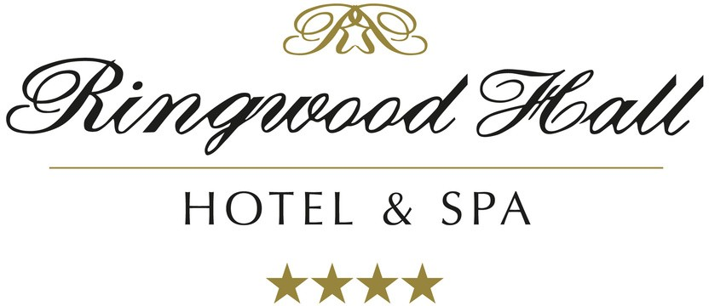
Served: 6.00pm-9.00

