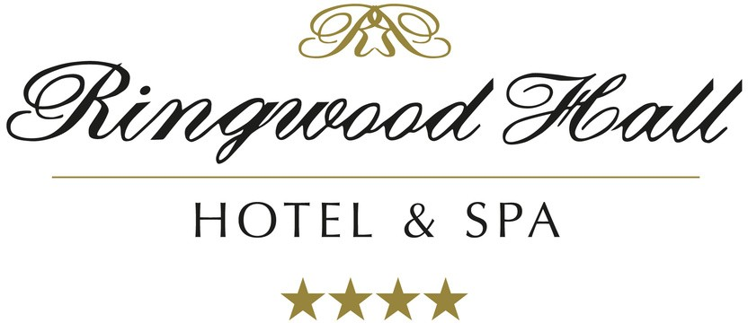
Breakfast Menu
Monday-Friday: 7.00am-9.30am Saturday-Sunday: 7.30am-10.30am Bank Holidays: 7.30am-10.30am

The Coach House
Full English Breakfast:
1 Pork sausage, 2 Bacon rashers, 1 Black pudding, 1 Air dried tomato, 1 field mushroom,
1 hash brown, portion of beans and a choice of either fried, scrambled, or poached egg £12.00
Separate items or extras charged at £1.50 per item, egg (Quorn sausage and gluten free sausages are available)

Choice of toasted brown or white farmhouse bread £1.00 each Bacon toasted sandwich £5.00
Sausage toasted sandwich £5.00
Field mushroom toasted sandwich £5.00
2 poached eggs on toast £5.50
Smoked salmon with scrambled egg and croissant £9.00
Smoked kipper with poached egg and lemon £7.50
Additional extras charged at £1.50 per item (hash brown, tomato, black pudding, bacon, sausage, fried or scrambled egg)
4 egg omelette £4.00
Additional extras charged at £1.50 per item (sausage, bacon, mushroom, onion, or cheese)
Porridge with a choice of yoghurt and blueberries, toasted coconut and mango or toasted almonds, banana, and maple £6.00
Croissant or selection of pastries £4.00

Eggs Benedict
Hot English muffin, pancetta, poached egg and hollandaise sauce £7.00
Eggs Florentine
Hot English muffin, wilted spinach, poached egg, and hollandaise sauce £7.50
Eggs Royal
Hot English muffin, smoked salmon, wilted spinach, poached egg, and hollandaise sauce £10.00

Please Note:
All dishes have complimentary glass of apple or orange juice and tea or filter coffee; Barista coffees will be added to the guest’s bill if ordered as an extra.

For any allergen advice please speak to a team member
Ringwood Hall Hotel & Spa - Brimington - Chesterfield - Derbyshire - S43 1DQ
T: +44 (0)1246 280077 E: reception@ringwoodhallhotel.com W: www.ringwoodhallhotel.com

